**School supplies required for French PY2/PY3(Base)**

**with Mr. Tremblay**

* Many of these materials you may have in good condition from past school years.***Please do not feel that you have to buy new materials every year*.**

**Required Supplies**

- **1 Binder**

- **1 set of dividers with 5 or more tabs**

- **4 Hilroy type notebooks (Writing, reading, 2 for homework)**

- **2 Bristol boards**

**- Pencils**

**- Erasers**

**- 2 or more highlighters in different colours**

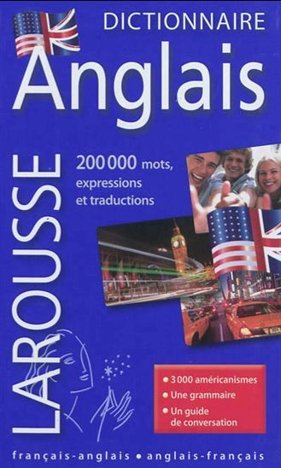- **1 French/English dictionary**

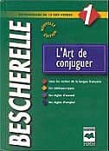*When purchasing a French/English dictionary it is important to check that there is a definition provided beside the translation. As in English, many French words meen more than one thing. For example the word *land* can mean *ground, earth, place* and it can meen the verb *to land*. Most inexpensive pocket dictionaries do not differenciate and give only a one word translation, for example *land* – *terre (earth)*. One word translations are insufficient at the high school level. Students require a pocket French/English dictionary (that includes definitions) for school use similar to this one

- **1 Bescherelle.** The following Bescherelle is recommended.

Bescherelle 1 L'art De Conjuguer

***\*The French/English dictionary and the Bescherelle are to be brought to all French classes!***

Optional supplies

Pencil case containing – different coloured pens, markers, ruler, correction tape (in place of liquid paper), post-it notes