**Matériel de classe**

**Français Secondaire 5 (Base)**

* Please verify for materials from past years that could be used this year. ***Please do not feel like you need to buy new materials every year*.**

**Required Supplies**

- 1 Binder

- 1 set of dividers with 5 or more tabs

- 4 Hilroy type notebooks

- Pencils

- Erasers

- Different color highlighters

**-** Post-its

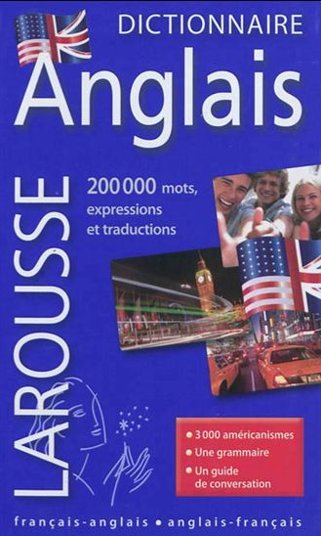**- 1 French/English dictionary**

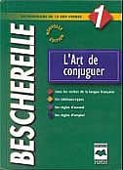*When purchasing a French/English dictionary it is important to check that there is a definition provided beside the translation. As in English, many French words meen more than one thing. For example the word *land* can mean *ground, earth, place* and it can meen the verb *to land*. Most inexpensive pocket dictionaries do not differenciate and give only a one word translation, for example *land* – *terre (earth)*. One word translations are insufficient at the high school level. Students require a pocket French/English dictionary (that includes definitions) for school use similar to this one

- **1 Bescherelle.** The following Bescherelle is recommended.

Bescherelle 1 L'art De Conjuguer

***\*The French/English dictionary and the Bescherelle are to be brought to all French classes!***